Guidance for Applicants

Introduction

The South Tyne Holistic Water Management Project (the South Tyne project) is a Northumbrian Water Group (NWG) Water Industry Environment Programme (WINEP) project to be delivered as part of NWG’s Asset Management Plan 7 (AMP7).

The way land is managed can have a significant impact on the wider environment. Agriculture, forestry, industry, minerals extraction and waste management can all have an effect on the quality of water abstracted from a catchment for treatment to supply drinking water. The South Tyne project will improve the quality of raw water in the catchment by restoring habitats and the natural processes operating in watercourses and connected land.

Natural habitats have a positive effect on water quality by, for example, retaining water in the environment for longer periods, thus allowing it to be filtered or ‘treated’ by natural processes, resulting in sediments or contaminants being removed or retained. Many of the water quality issues seen in the South Tyne catchment are related to extreme weather events i.e. flood and drought leading to variability in conductivity and release of pollutants. Reducing the frequency of these events may result in improved water quality as well as an increased ability for the catchment to adapt to climate change.

NWG would like to deliver the South Tyne project in part by funding partner organisations, farmers and landowners to deliver projects which will achieve the project’s aims.

NWG retains the right to change the funding criteria set out below as necessary to deliver the overall aims of the South Tyne project.

Level of Grant

Grants will be offered up to a value of £25,000. Applications for larger sums may be considered if there is a strong justification for doing so – please contact Susan Mackirdy susan.mackirdy@nwl.co.uk to discuss before submitting an application in excess of £25,000.

Depending on the type of project, the level of funding, and the applicant’s requirements, grants will be paid either up-front, phased or upon completion of works. This will be agreed prior to the project and associated grant being approved.

Timescales.
Applications should be submitted using the designated application form. Applications will open on 20th May 2021 with the first deadline being noon on the 28th June 2021 with a decision given in mid-July. Further information on the timing of the next round of grants will be released in July 2021.
The timescale for delivery will be included in the agreement for individual grants. This would normally be within 18 months although longer projects would be considered provided they are completed by the end of the project period - December 2024.

Eligibility

Projects should be within the South Tyne Catchment project area (Map 1) and should result in positive improvements in the following criteria -

Biodiversity
• Actions resulting in habitat creation, improvement, expansion or increased connectivity between Section 41 NERC Act Habitats of Principal Importance and/or
• the increased distribution, recovery and resilience of priority species in the catchment compared to current distributions.
AND

Water Quality and Natural Flood Management
• The creation of natural flood management interventions or actions which have been shown to reduce peak river flows (interventions are as defined for e.g. in the SEPA Natural Flood Management Manual 2015 or the EA / cbec Natural Flood Management Toolbox 2017 or similar). Reducing peak (and low flows) benefits water quality by reducing the variability of the characteristics of the water such as conductivity and reduces point and diffuse pollution and/or
• the creation of interventions or actions which have been shown to reduce water pollution from agriculture (as defined for e.g. in the Defra DWPA Mitigation Manual 2011) forestry (as defined for e.g. in the UK Forestry Standard) and other land management uses targeting especially the release of sediments and other land use based contaminants. These interventions may include options such as treatment wetlands or structures, riparian buffers and other sediment-releasing ‘slowing the flow’ interventions and/or
• the creation of interventions or actions which would reduce the potential for contaminants from other land uses, including abandoned industries, from entering the river environment and/or
• the re-establishment of natural river forms and processes at locations where natural geomorphological processes have been disrupted.

Projects will also receive an additional positive score if they can demonstrate:
Climate Change Resilience
• An increase in the ability for the catchment to mitigate against and adapt to climate change (as detailed for e.g. by the Natural England Climate Change Adaptation Manual 2020) and/or
• an increase in the resilience of priority habitats likely to be adversely impacted by climate change such as ponds, wet woodlands or headwater streams with a limited catchment area.

Feasibility studies, educational and/or other out-reach type projects will be considered provided they are likely to result in the development of projects which would meet these criteria.

Project Area
The project area is as shown in Map 1.

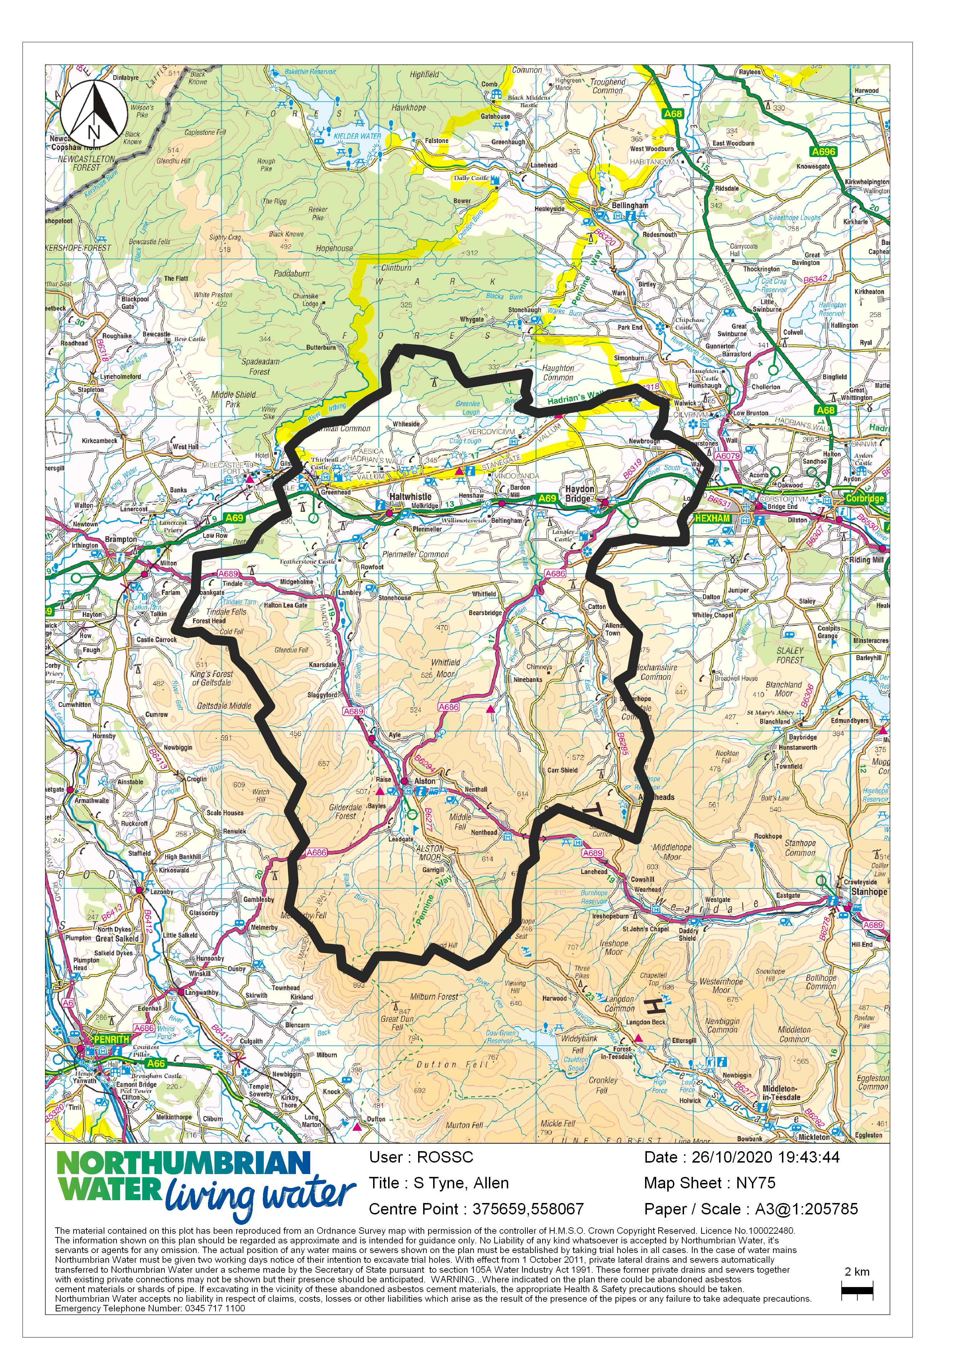

Map 1

Additional criteria

Consents
Applicants should indicate if they have obtained the consent of the landowners and/or tenants to carry out the project and include a list of the other necessary consents and permissions required and what measures will be taken to obtain these prior to the project commencing.

Health and Safety
Applicants should provide evidence that they are able to complete the works in a safe manner having considered the necessary health and safety legislation and CDM Regulations as necessary.

Feasibility studies
Feasibility studies may be funded providing there is a reasonable expectation that the outcome will lead to the future delivery of a project.

Educational, surveys and outreach projects may be funded providing it can be shown that these would likely result in an increased knowledge and/or changes in behaviour that would result in positive outcomes listed in the criteria or future potential spin-off projects.

Projects which have already started
It is not anticipated that the project will fund works which have already started, or to fund ongoing maintenance, especially where this may be reasonably funded under Countryside Stewardship or other established grant schemes. Applicants should also ensure that projects are not double funded.

Evaluation
Applicants are required to consider how they will evaluate the success of their project. This may involve the carrying out of ecological surveys before the start of the project and before the end of 2024. For larger and longer projects, ecological surveys using existing or new data may need to be carried out as part of the project. The costs of such studies can form part of the application for funds.

Consideration should be given to the employment of DEFRA’s Biodiversity Net Gain metric or similar. For smaller projects where evaluation would be proportionally expensive, or where the organisation does not have the ability to complete or commission evaluation, support from the wider project team may be offered across a number of smaller schemes.

Project Selection

Projects will be selected by an internal NWG panel comprising representatives from Water Resources, Conservation, Innovation, and Environmental Partnerships based on the project scoring detailed below.

Project Scoring

It is likely that the fund will be competitive and qualifying projects will be scored on the following basis:

Overall Project Impact
A score will be given as to how well the project meets the overall project objectives.

Projects should demonstrate biodiversity enhancements AND improvements in water quality / natural flood management.

Projects which also demonstrate climate change resilience will receive an additional score.

Efficiency
Applicants should give a full breakdown of all costs including any costs for materials, contractor or staff costs, and details of any match funding with a summary of the level of grant applied for. Please provide estimates received for works if appropriate. For applicants that are able to recover VAT please indicate this.

Applicants will be expected to apply for other funds where these would be more normally sought. For example, where woodland creation can be funded from the Woodland Creation grant then this should be sought. The South Tyne project funds may be used to ‘top-up’ Woodland Creation grants to cover non-eligible items such as Black Grouse tags or stock-proof fencing on difficult slopes, or where woodland planting is not eligible e.g. below the threshold hectarage.

Match Funding
The South Tyne Holistic Water Management Project is a partnership project and partners are encouraged to provide some match funding. Gifts in kind, such as volunteer time, are valid match funding. Projects will be scored on a sliding scale depending on the level of match. Projects without any match funding will still be considered but will score very low on this criterion.

The time that volunteers give to support the delivery of the project should be calculated as follows:
• professional volunteer (for example, accountancy or teaching): £50 per hour
• skilled volunteer (for example, leading a guided walk): £20 per hour
• volunteer (for example, administrative work): £10 per hour.

Maintenance Sustainability
Projects which are self-maintaining or where the ongoing provision for maintenance has been considered will score highest. Those for which ongoing maintenance has not been considered will score the least.

Partner Support
Projects which demonstrate support by the local community, the land manager/owner, governmental or non-governmental environmental organisations will score more highly. Please provide letters of support if available.

Education / Demonstration
Applicants who are willing to provide demonstration sites or host site visits, or where public access is available will score more highly.

Community Benefit
An additional score will be awarded for projects which can demonstrate a contribution to a broad range of benefits which would result in greater community cohesion and resilience.
Research and Innovation
Projects with applicants who are willing to assist with research – for example, working collaboratively with educational institutions, identifying areas for study, agreeing to take part in research including for example collecting water samples, allowing access, or by agreeing to have information on their project published - will score more highly .

Projects which have a novel or innovative approach will be scored highly providing there is a reasonable expectation that the project can be implemented successfully.

Viability and Spin-offs
Projects which will result in other spin-off projects or may not happen without funding from the South Tyne project will receive the highest score.

Evaluation
Projects which have arrangements for project evaluation, for example carrying out ecological surveys, will be scored more highly.

Standard Terms and Conditions for Selected Projects
- Before making an application, applicants should ensure they have the landowners/tenant’s permissions and have identified what other consents and permissions are required and how these will be obtained. Applicants may supply supplementary documents showing the support of organisation’s from which consents are required.
- Works must be carried out in a legally compliant manner having regard to health and safety and safe methods of working.
- NWG’s contribution must be acknowledged in all public communications, including press releases and social media, and NWG’s logo must be used on project material and interpretation. Press releases and articles must be agreed with NWG’s communications team.
- A report on the progress of the project must be submitted to NWG every six months and/or on project completion (whichever occurs first) and should include copyright-free photographs which can be used by NWG to promote the South Tyne project.
- Project reports must provide evidence of where the project money provided by NWG has been spent and any unspent funds should be returned to NWG at the end of the project.
- Project reports must provide information on specific measurable project outputs as agreed with NWG before the project starts.
- All successful project applicants will sign a partnership agreement agreeing to the above terms. Additional requirements may be agreed specific to each project.

